* 1. 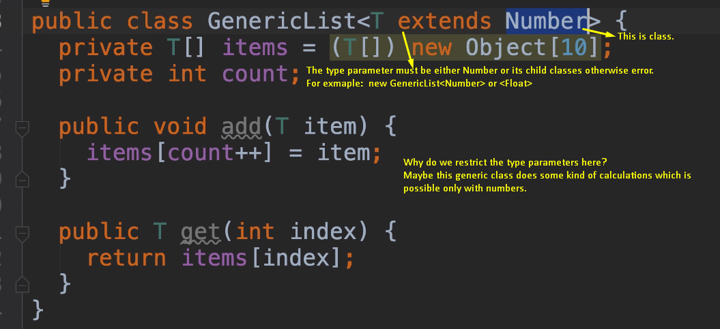
  2. 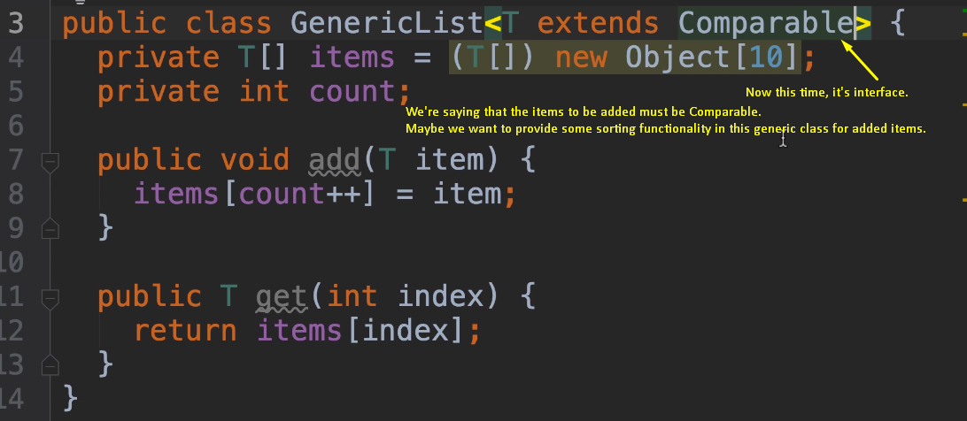
  3. 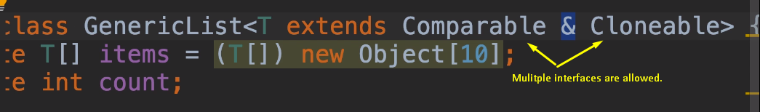
  4. This type parameter is **bounded type parameter**.
  5. Here T type parameter is bounde.